**Three Tier Application**

Step 1 = First create a database.

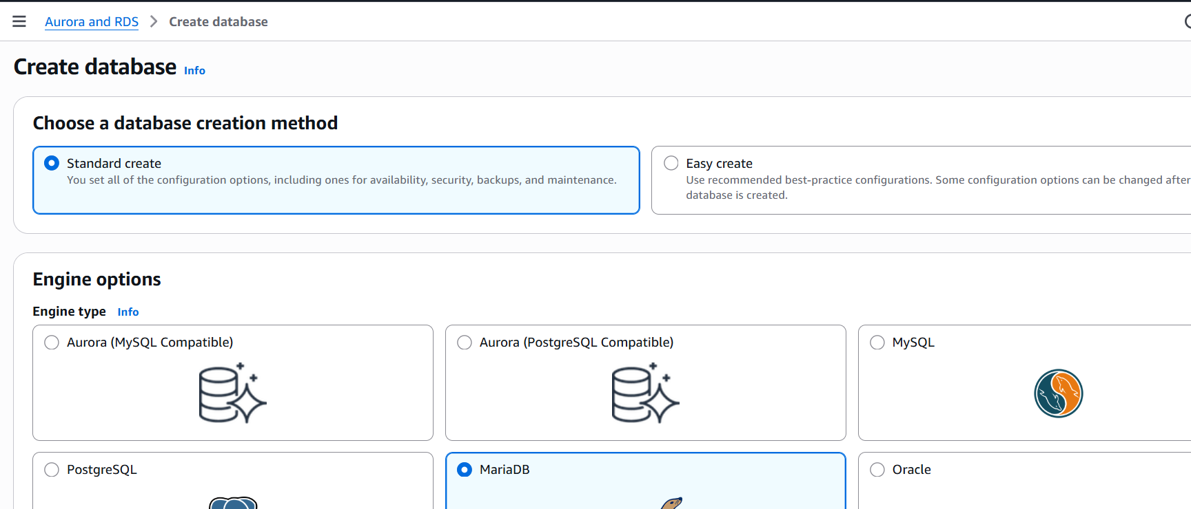

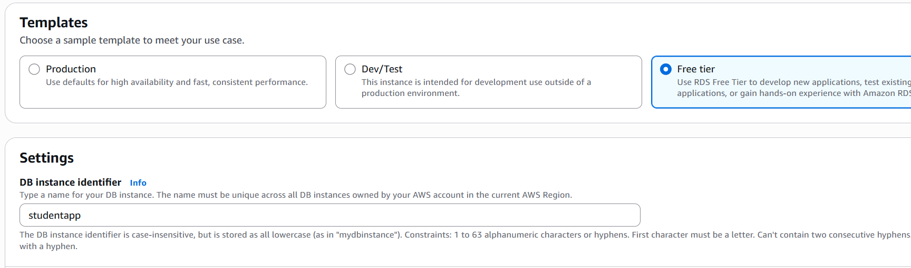

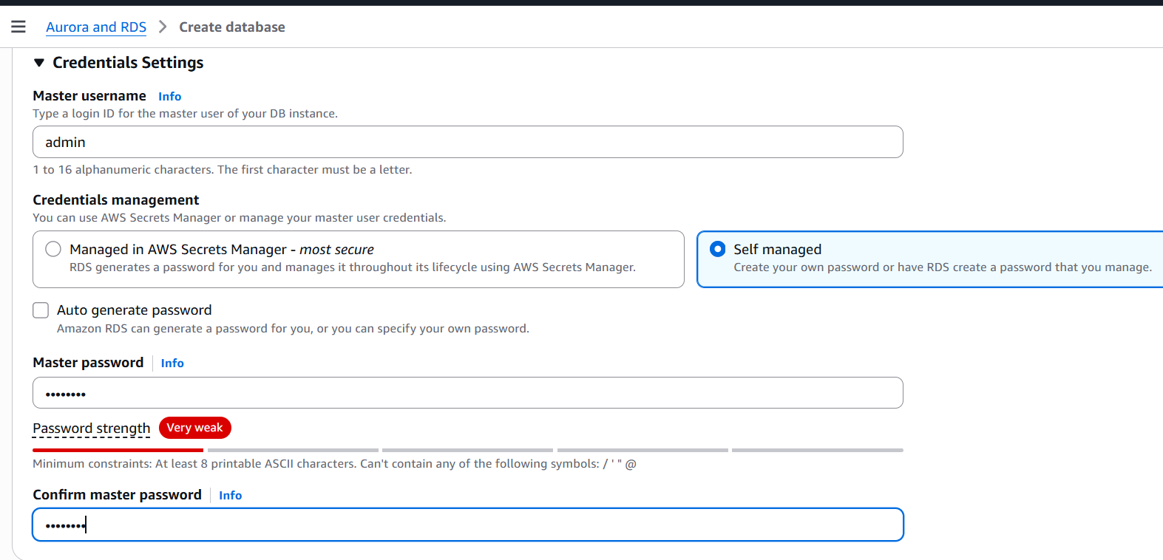

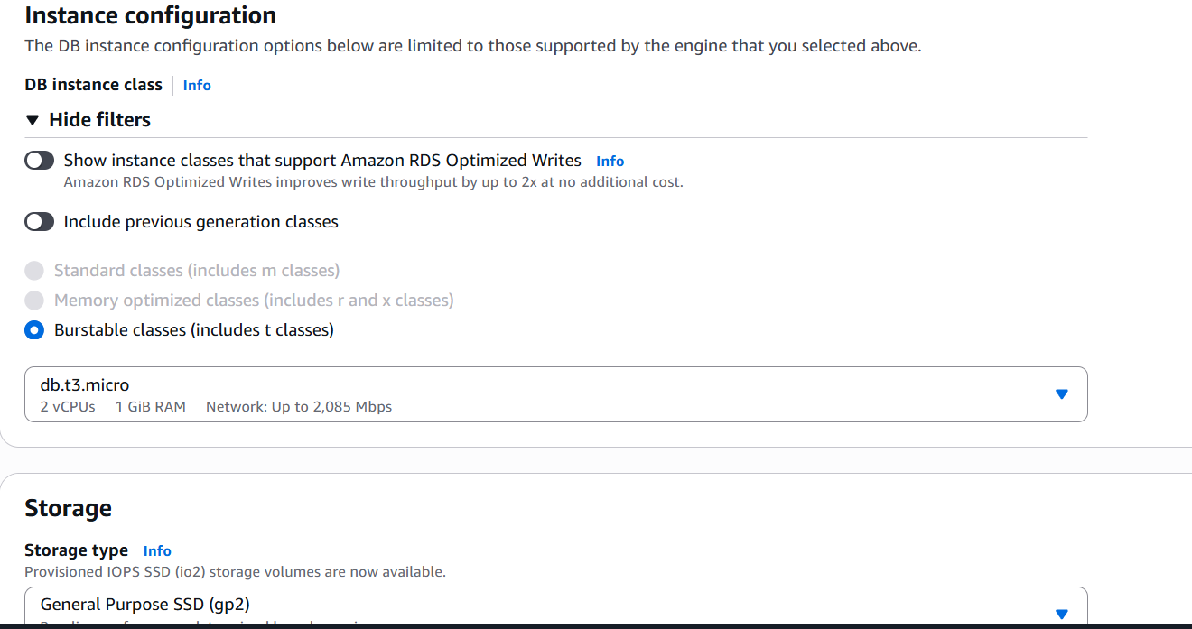

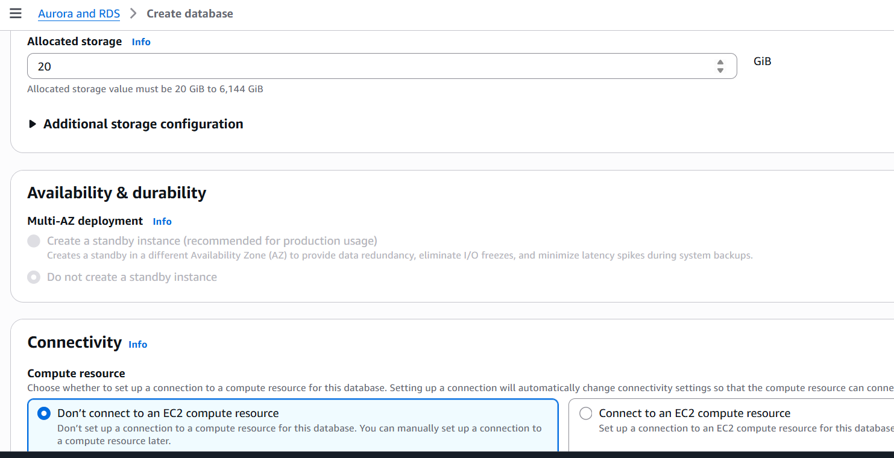

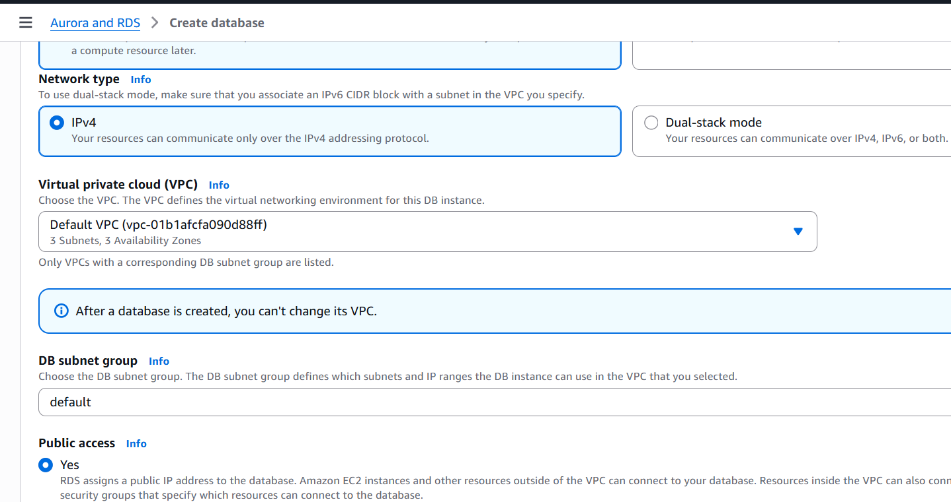

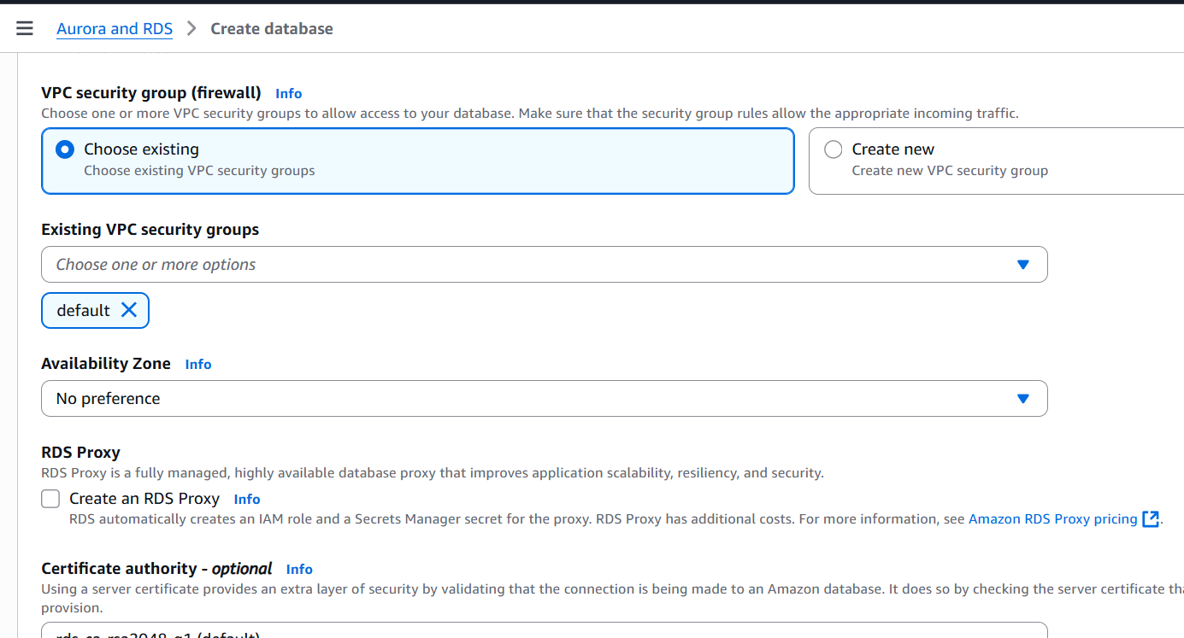

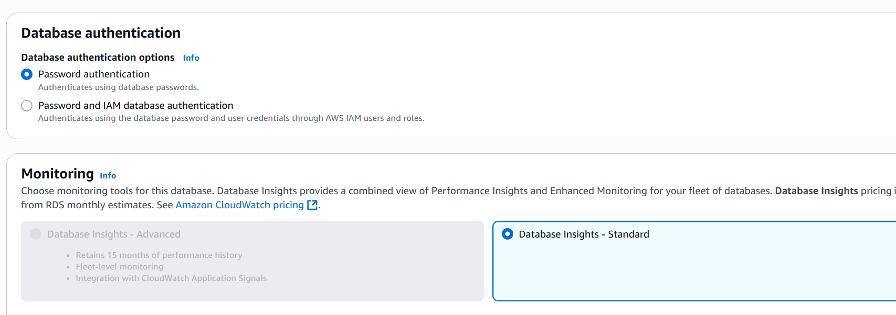

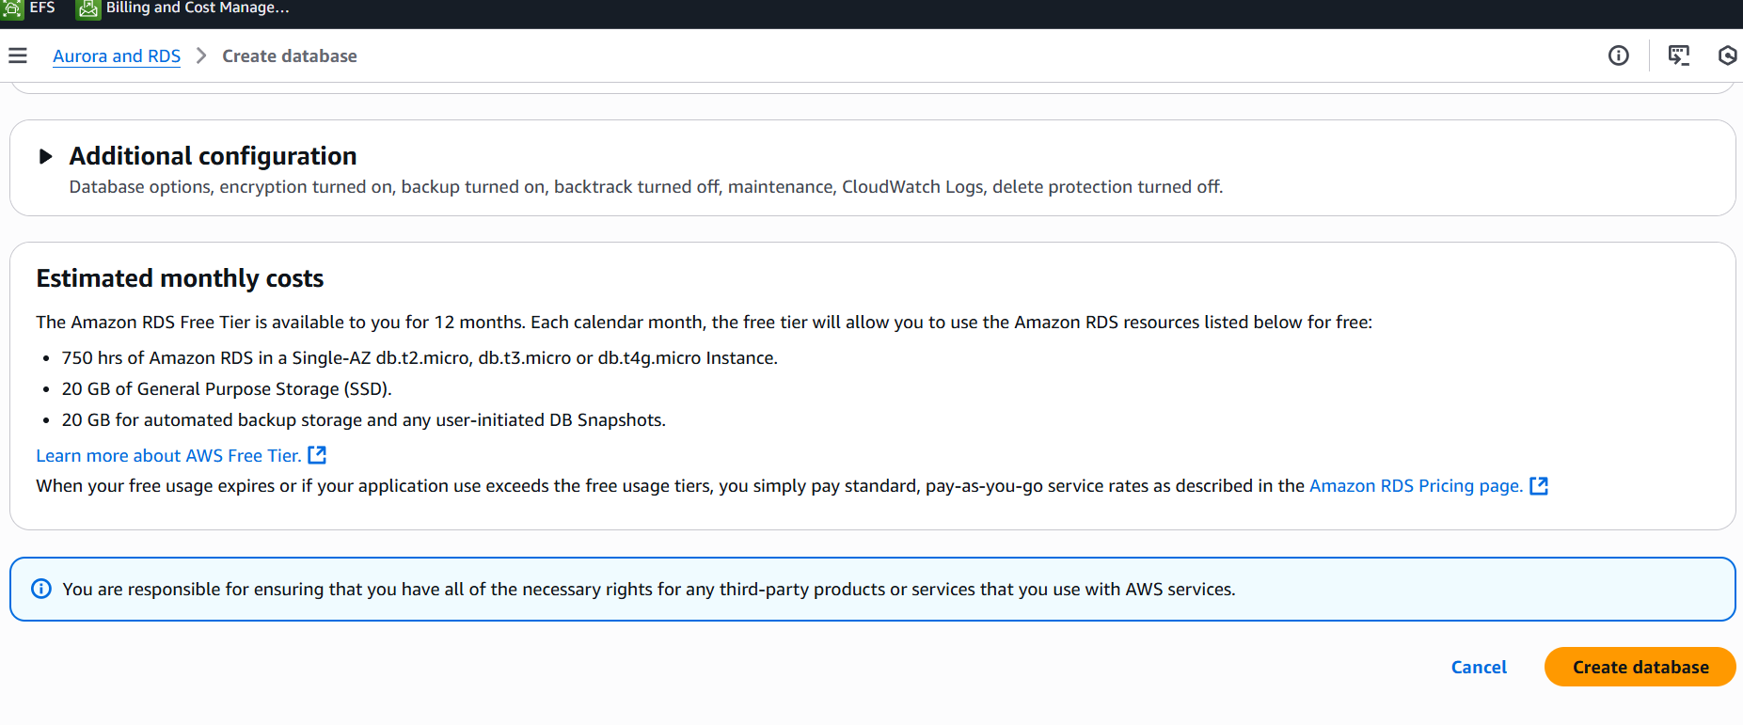

Step 2 – Create your EC2 instance.

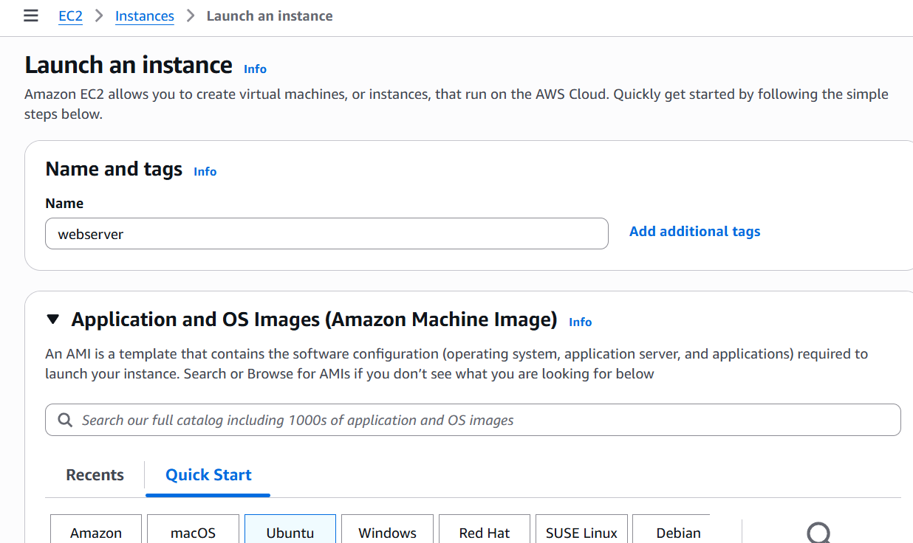

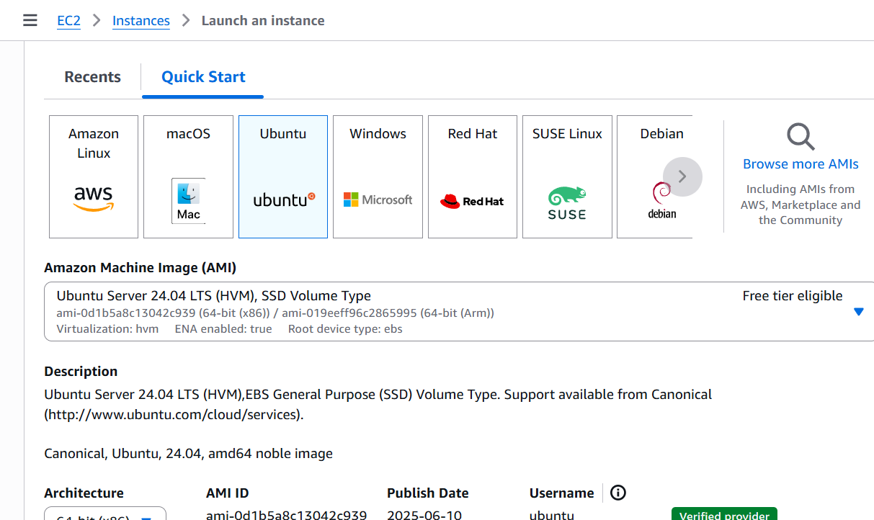

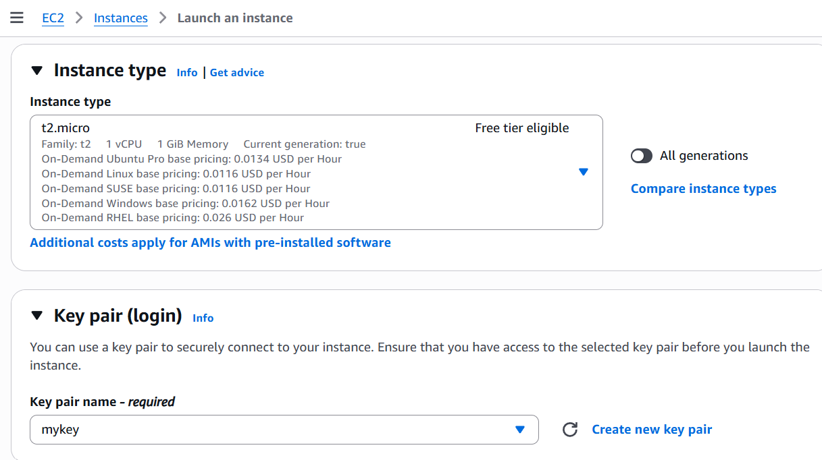

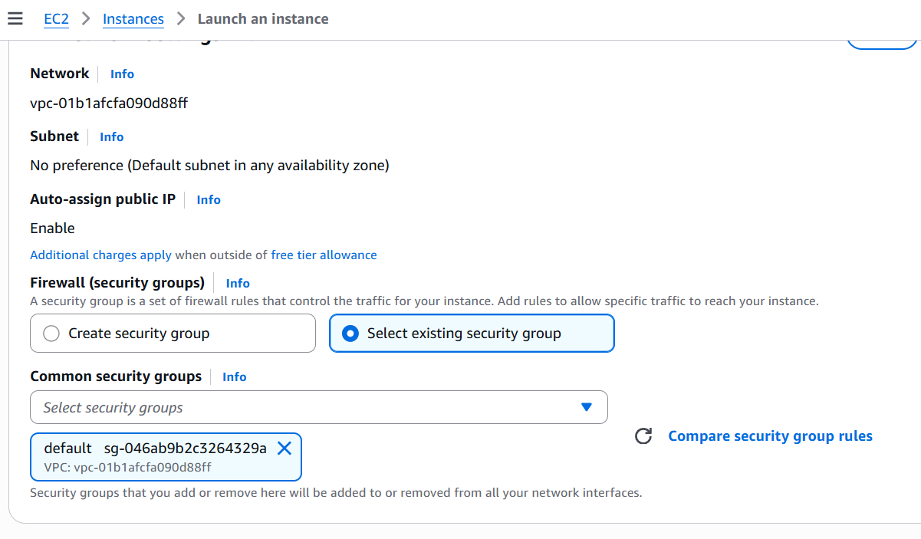

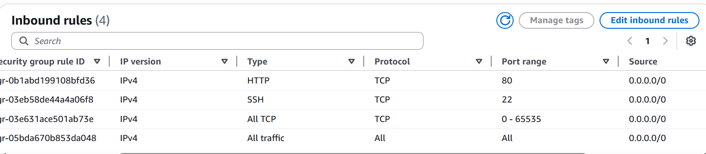

Now need to install MySql Client in our server.

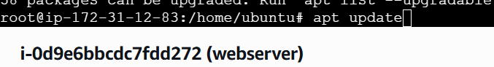

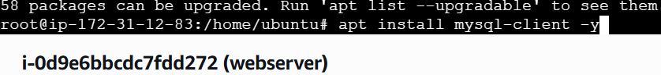

Once its install connects with your database.

Mysql -h host-id of databse -u mastername -ppassword



Now create database on your server, this is because in our project we define name as student_db otherwise no need to do this.

CREATE DATABASE student_db;

GRANT ALL PRIVILEGES ON springbackend.* TO 'username'@'localhost' IDENTIFIED BY 'your_password';



Now clone your github to server

Git clone github-httpd-link



First we are gonna deploy backend, so go to backend floder.

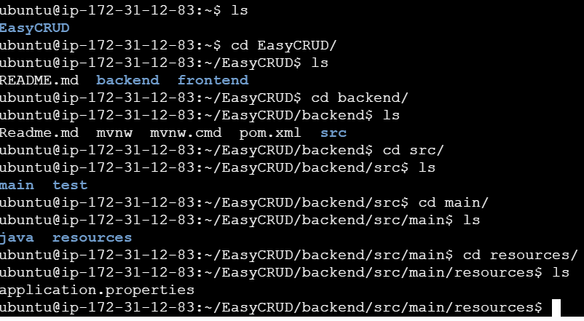

In this file change your DB host , master name , Password.

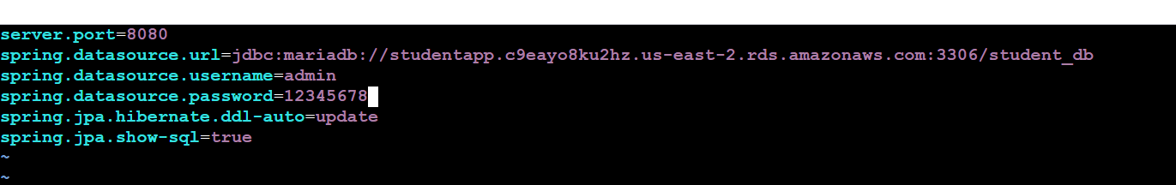

Now install java. Because our API is in Java.

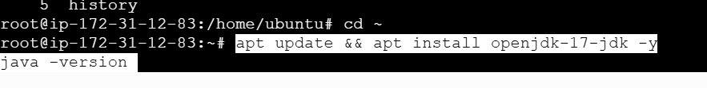

Install Maven build tool for java.



Now clean maven package, so that we can get the jar file.

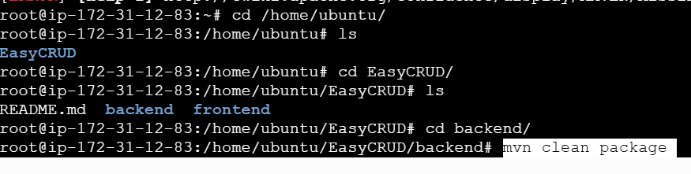

Run your student Jar file.

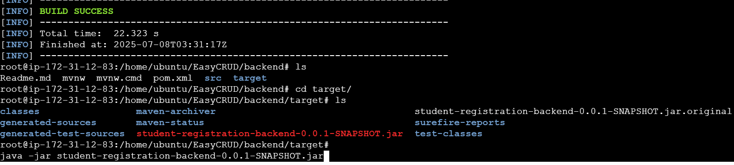

Backend is deployed successfully.

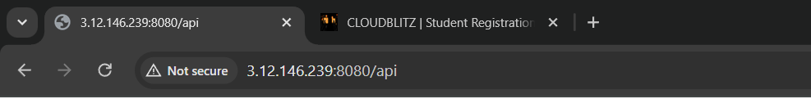

Now we are gonna deploy frontend. For that install node JS because frontend is in React.



Under env file and change the PUBLIC IP with your server IP.





Now install NPM for React.



Run your NPM.



Now install Apache Build tool for frontend.

apt install apache2 -y

systemctl start apache2

cp -rf dist/* /var/www/html/



Now finally run your public IP on browser and try to register student data.

Application link = http://3.12.146.239/

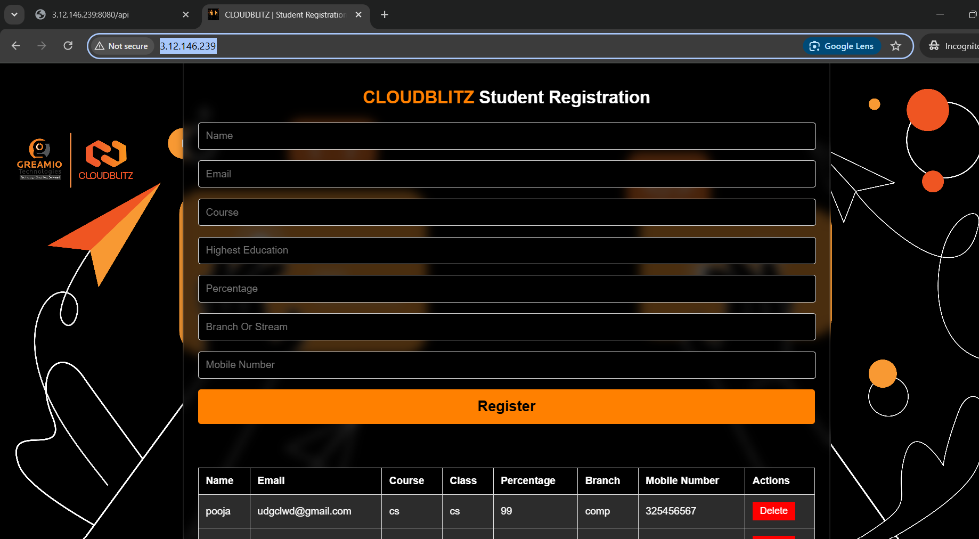

In our database we can see all the registered data.

